
MAX INFRASTRUCTURE LIMITED

Ref: MIFL/SC/2024/10/02
Tel : +88 02 55058345, 55058346
+88 02 223388646
Ip : +88 09614999333
Fax : +88 02 471J0176
Email : info@maxgroup-bd.com Web : www.maxgroup-bd.com

Date: 02-10-2024

To Whom It May Concern
This is to certify that, MD. Abul Kalam Azad, bearing ID: 100007589 is a permanent employee of Max Infrastructure Limited and working from 15th July 2019 to till date as Assistant Manager, Internal Audit. He draws BDT 85,000/- per month as net salary.
His Salary Structure per month is as follows:
Basic : 33,999 BDT
House Rent : 30,001 BDT
Medical : 8,000 BDT
Conveyance : 8,000 BDT
TA/DA : 5,000 BDT
________________________________________
Total Gross Salary : 85,000 BDT Only

We are issuing this letter on the request of our employee for banking purposes without accepting any liability on behalf of this letter or part of this letter on our organization

Sincerely Yours,
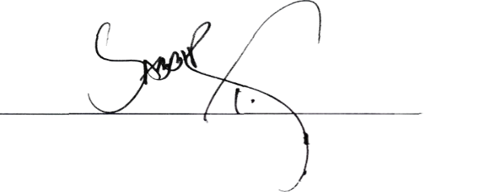


Sabbir Haider Taposh Executive, Human Resources Contact: +880 1713 197847

Corporate Office : RAOWA Complex, Level-11,VIP Road, Mohakhali, Dhaka-1206, Bangladesh Head Office : Baitui Hossain Building (6th Floor), 27 Dilkusha Commercial Area, Dhaka-1000, Bangladesh

